## About Project (**apiTestsFromTestRail)**

Project apiTestsFromTestRail – this is a project written on Java, and run automation test of API by integration with TestRail.

To the start, after connection to TR script will send : id of test suite from TestRail. Test will access to all test cases and run test and analysis of all required info

1) title. Allways will start with request “GET,POST,DELETE” if it starts from GET (if will starts GET-request etc.). When {{URL}}, and it will be replaced with server URL

2) Steps. If request have any steps to execute it will be added to steps area.

3) Expected Result. Contains expected json response

Received results test will compare with expected , if after compare no differences - it will change the result of the test to Pass, if not, change to Failed and add some comments to explain a failure from test log

Test Method located in class file: apiTests.ApiTest.

Package utils contains supported files for connection to TestRail, read config/property and send it to the server

## Configuration:

To build a project we use Maven. To start bat file need to start bat file in root(test) directory:

mvn clean test -Dprops="testRailAppBus.properties" -DprojectId="5" -DsuiteId="22" -DserverUrl="https://dev.e-dapt.net:5554" -Dpassword="maps511"

|  |  |
| --- | --- |
| **Параметр** | **Назначение** |
| **-Dprops** | Path to property file |
| **-DprojectId** | Project Id on TestRail |
| **-DsuiteId** | Suite Id on TestRail |
| **-DserverUrl** | URL to the server |
| **-Dpassword** | Password to TR |

## Property file ( will look similar):

**url**=**https://appbus.testrail.io**

**email**=**qauser@appbus.com**

**applicationName**=**API Validation Sanity Test**

**certFileName**=**Qalaborate.pfx**

**certPassword**=**Qalaborate**

|  |  |
| --- | --- |
| **Параметр** | **Назначение** |
| **url** | Link to TestRail |
| **email** | Email for login to TR |
| **applicationName** | Name of the Project on TR |
| **certFileName** | Path to cert file |
| **certPassword** | Password for cert |

To change the address of the server to which API tests will access, need just to change the value of the -DserverUrl parameter in the start command script and, if another certificate is used on this server, then change the values of certFileName and certPassword in the specified property file.

## Steps to Run (preconditioning)

:

1. Open Postman to connect to the environment:

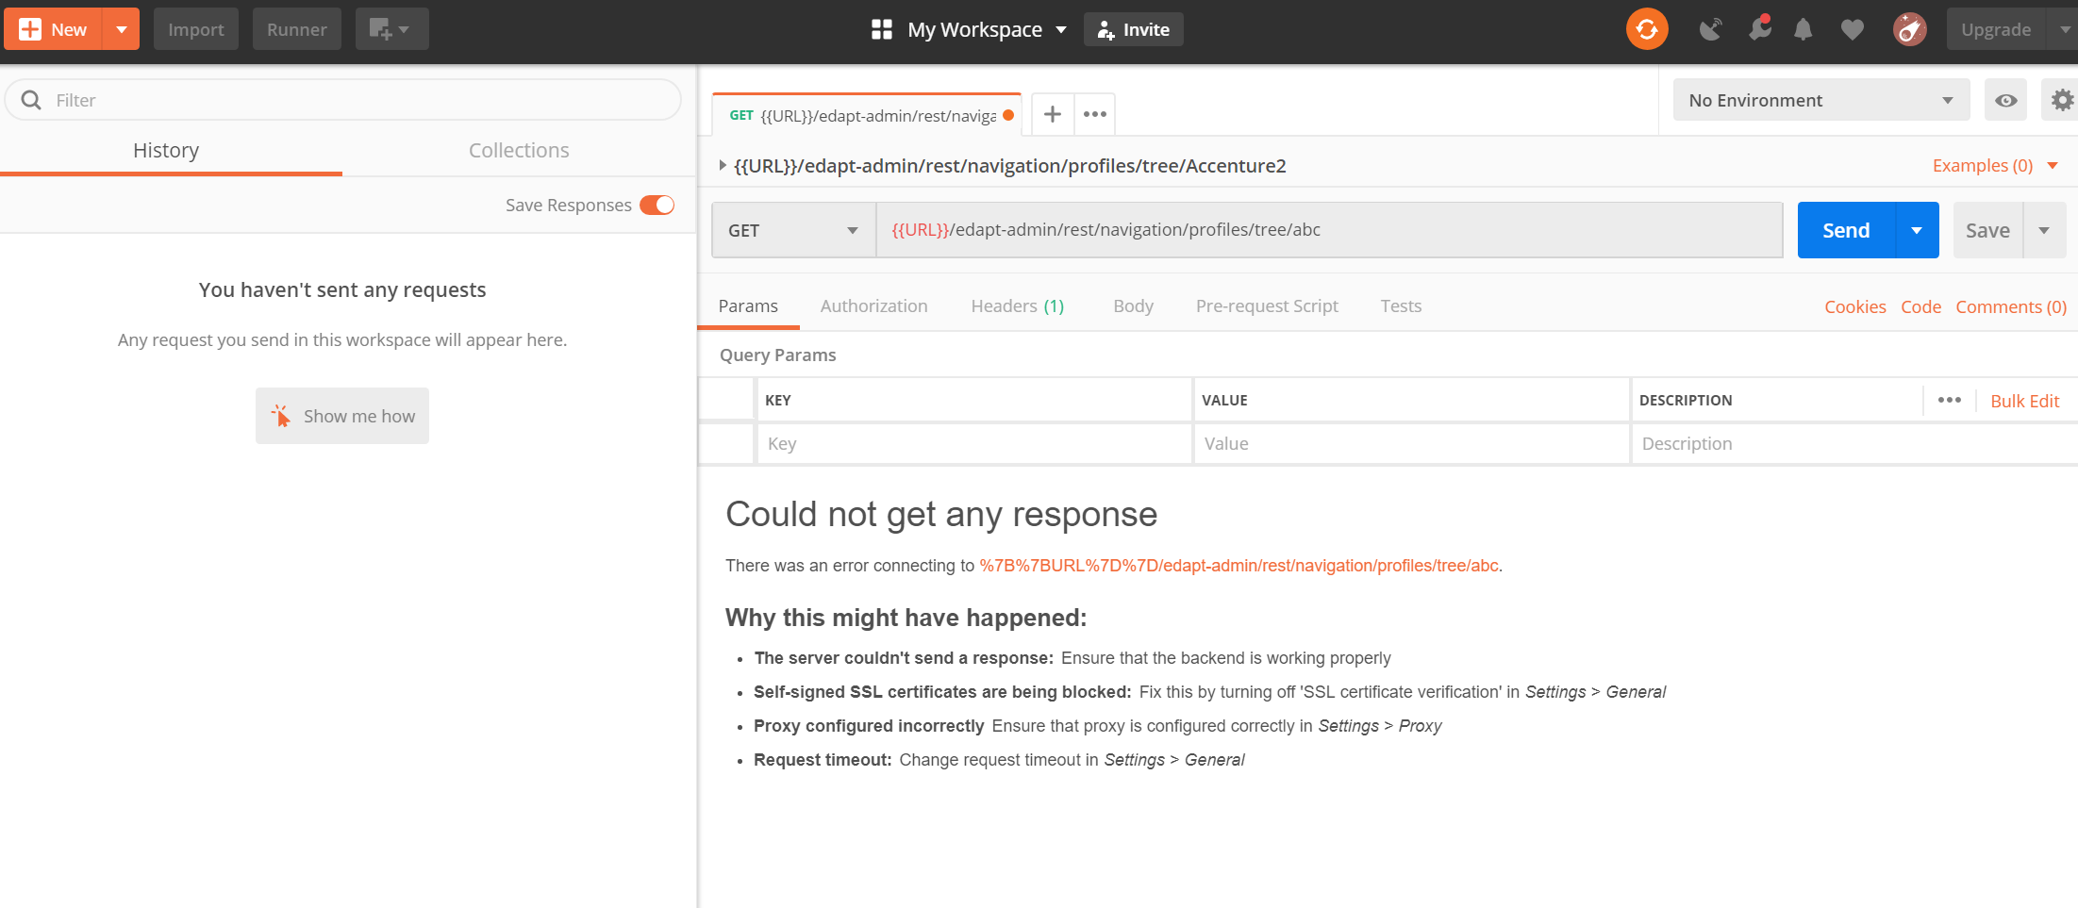

Upload collection files from C:\automation\API_Postman

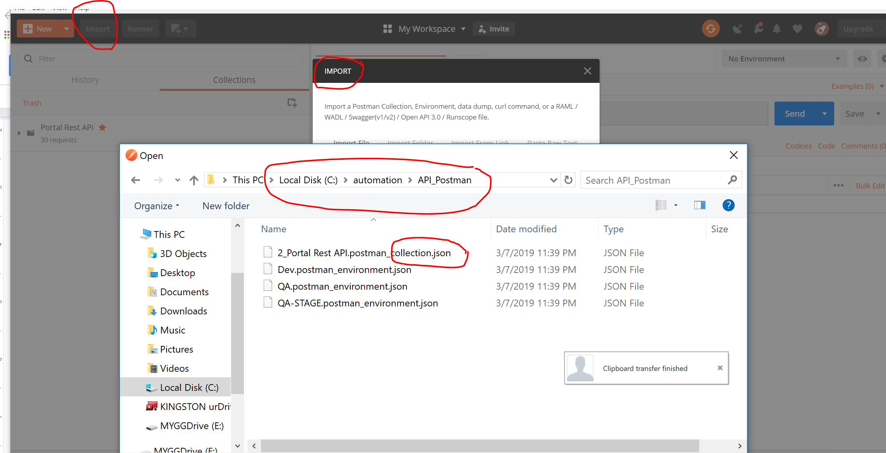

When set an environment:

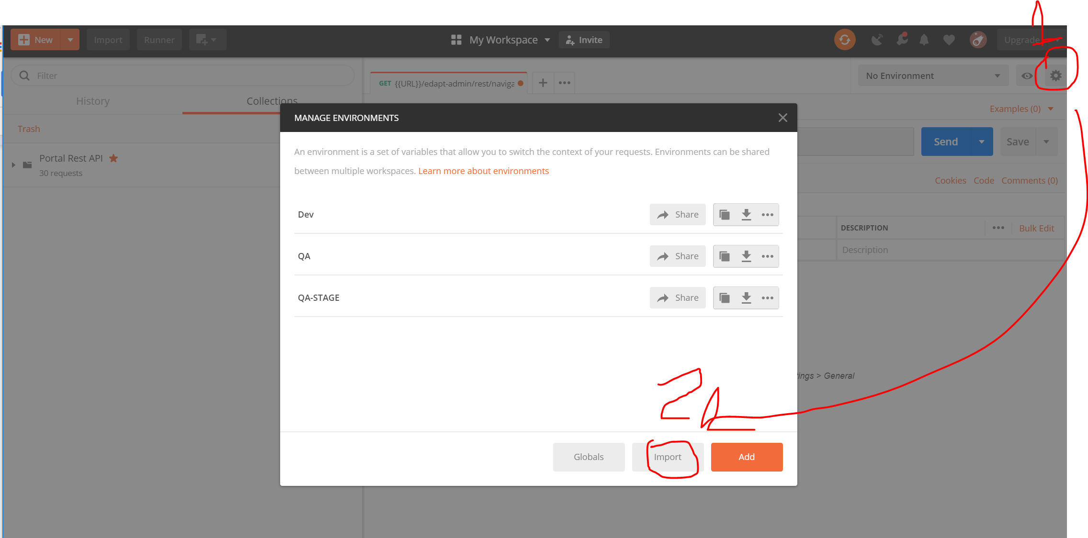

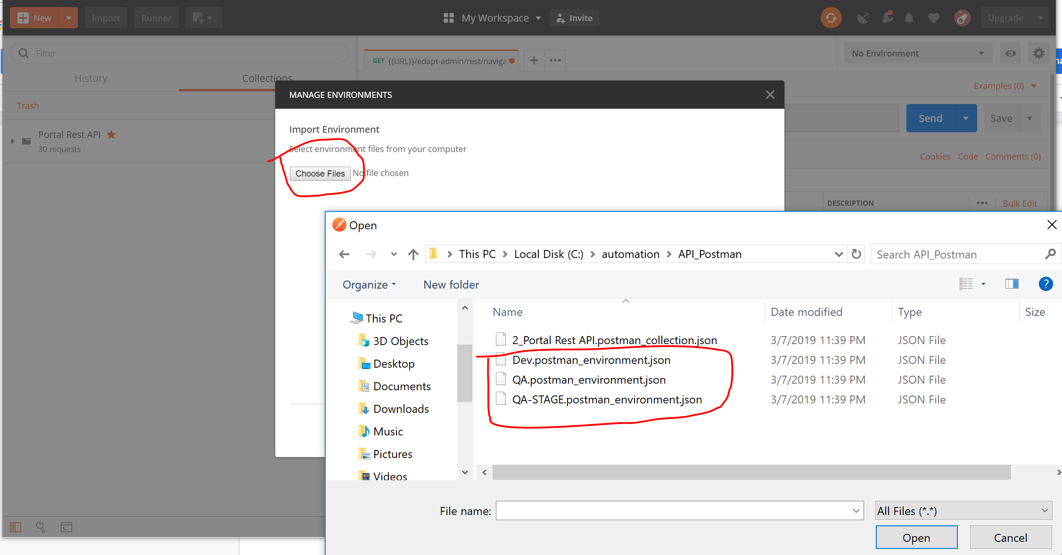

Disable a SSL validation for the testing purpose:

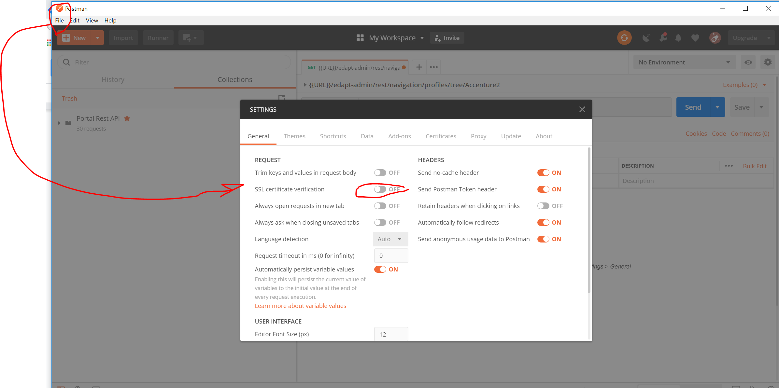

Before run any test make sure you connected on OpenVPN!!! *****

When run first test : Get run first to get First result

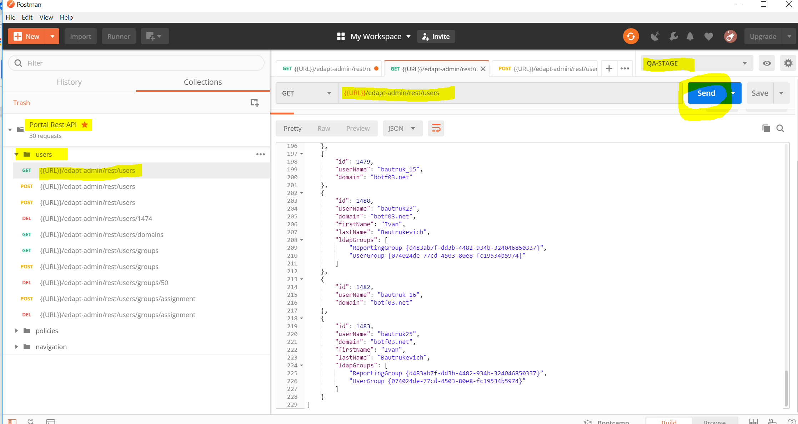

Collect infomation about last user ID (we will need to change it in delete user test case:

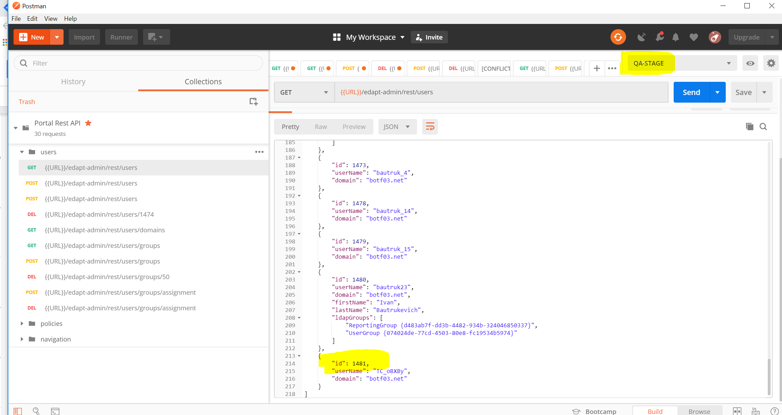

Before run test in TeamCity change ID for the user need to be delited:

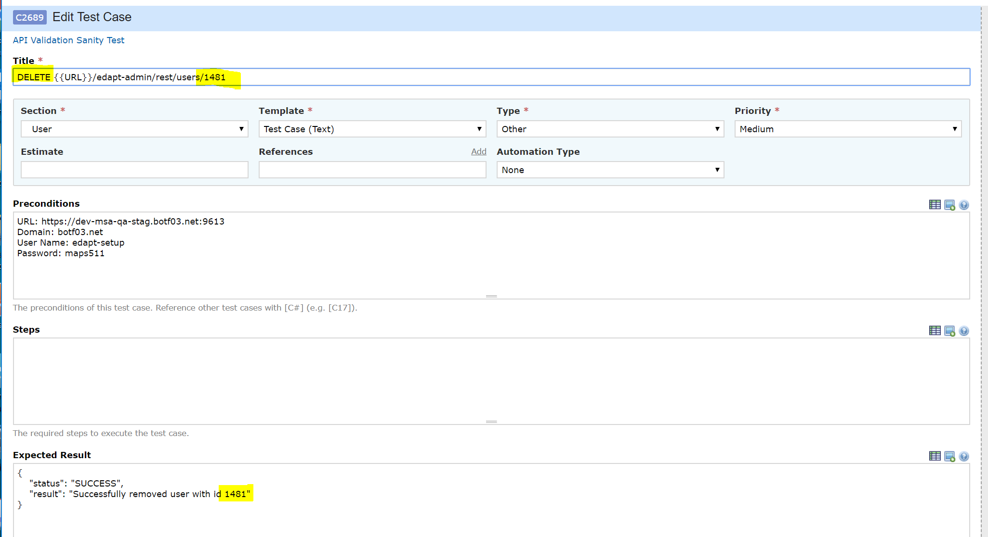

Start TeamCity test run:

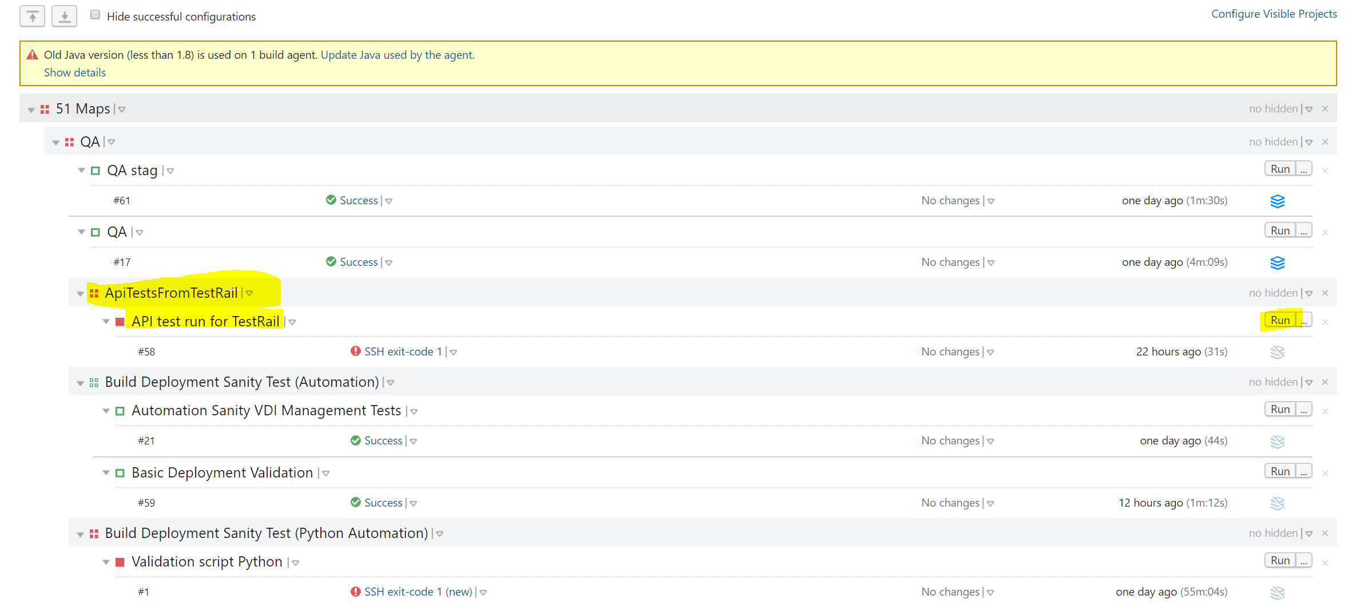

Test report will be opened it TestRail Run:

